Name : Rajvardhan Reddy
Reg No : 180905093
Sec : B
Roll No : 19

OS LAB - 5 : IPC -1 – PIPE, FIFO

P1) Write a producer and consumer program in C using the FIFO queue.
The producer should write a set of 4 integers into the FIFO queue and
the consumer should display the 4 integers.

Code :
Producer :
#include <stdio.h>
#include <stdlib.h>
#include <unistd.h>
#include <sys/types.h>
#include <limits.h>
#include <fcntl.h>
#include <sys/msg.h>
#include <sys/stat.h>
#include <string.h>
#define FIFO_NAME "my_fifo"
#define BUFFER_SIZE 1000
int main(int argc, char *argv[])
{
int pipe_fd;
int res;
int open_mode = O_WRONLY;
int n = 0;
char buffer[BUFFER_SIZE + 1];
if (access(FIFO_NAME, F_OK) == -1)
{
res = mkfifo(FIFO_NAME, 0777);
if (res != 0)
{
fprintf(stderr, "Could not create file%s\n",
FIFO_NAME);
exit(EXIT_FAILURE);
}
}
printf("Process %d opening FIFO O_WRONLY\n",
getpid());
pipe_fd = open(FIFO_NAME, open_mode);
printf("Process %d result %d\n", getpid(), pipe_fd);
if (pipe_fd != -1)
{
printf("Enter 4 numbers\n");
while (n < 4)
{
scanf("%s", buffer);
res = write(pipe_fd, buffer, BUFFER_SIZE);
if (res == -1)
{
fprintf(stderr, "Write Error on Pipe\n");
exit(EXIT_FAILURE);
}
n++;
}
(void)close(pipe_fd);
}
else
exit(EXIT_FAILURE);
printf("Process %d Finished\n", getpid());
exit(EXIT_SUCCESS);
}

Consumer :
#include <stdio.h>
#include <stdlib.h>
#include <unistd.h>
#include <sys/types.h>
#include <limits.h>
#include <fcntl.h>
#include <sys/msg.h>
#include <sys/stat.h>
#include <string.h>
#define FIFO_NAME "my_fifo"
#define BUFFER_SIZE 1000
int main(int argc, char *argv[])
{
int pipe_fd;
int res;
int open_mode = O_RDONLY;
int n = 0;
char buffer[BUFFER_SIZE + 1];
memset(buffer, '\0', sizeof(buffer));
printf("Process %d opening FIFO O_RDONLY\n",
getpid());
pipe_fd = open(FIFO_NAME, open_mode);
printf("Process %d result %d\n", getpid(), pipe_fd);
if (pipe_fd != -1)
{
do
{
res = read(pipe_fd, buffer, BUFFER_SIZE);
printf("%s\n", buffer);
n++;
} while (n < 4);
(void)close(pipe_fd);
}
else
exit(EXIT_FAILURE);
printf("Process %d Finished, %d bytes read\n",
getpid(), n);
exit(EXIT_SUCCESS);
}

Output :

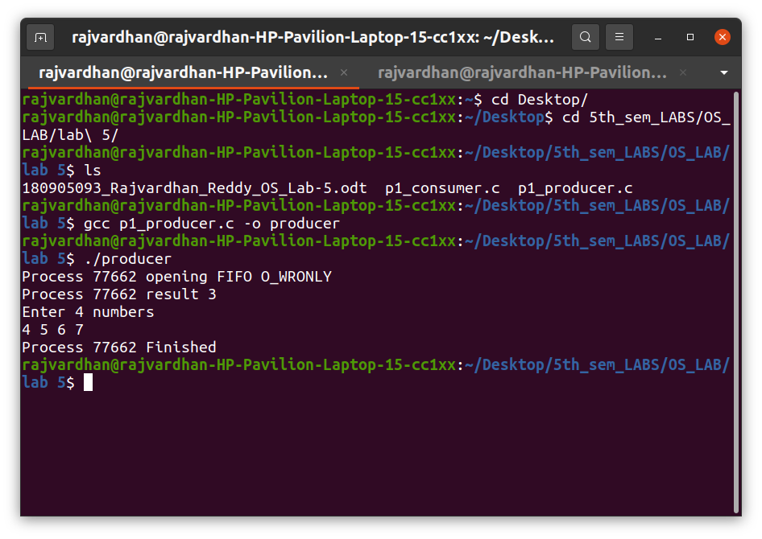
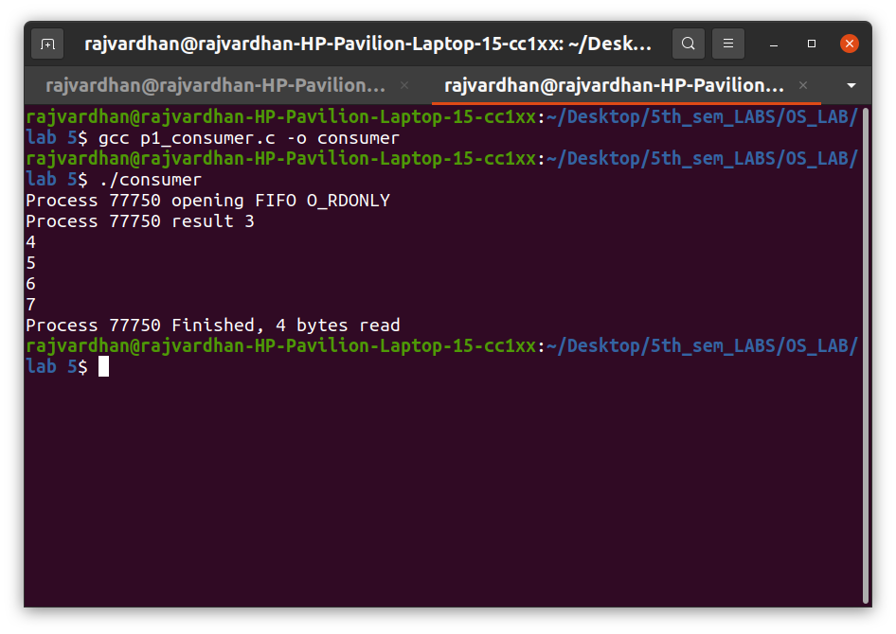

P2) Demonstrate creation, writing to, and reading from a pipe.

Code :

#include <stdio.h>
#include <stdlib.h>
#include <unistd.h>
#include <sys/types.h>
#include <sys/ipc.h>
#include <sys/msg.h>
#include <string.h>
int main(int argc, char *argv[])
{
int n;
int fd[2];
char buf[1025];
char *data = "Mid Term Lab Exams from tomorrrow!";
pipe(fd);
write(fd[1], data, strlen(data));
if (n = read(fd[0], buf, 1024) >= 0)
{
buf[n] = 0;
printf("Read %d bytes from pipe\"%s\"\n", n, buf);
}
else
perror("Read");
exit(0);
}

Output :
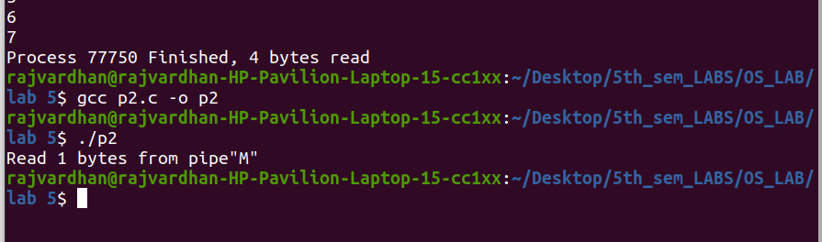

P3) Write a C program to implement one side of FIFO.

Code :
User 1 :
#include <stdio.h>
#include <stdlib.h>
#include <unistd.h>
#include <sys/types.h>
#include <limits.h>
#include <fcntl.h>
#include <sys/msg.h>
#include <sys/stat.h>
#include <string.h>
#define FIFO_NAME "my_fifo"
#define BUFFER_SIZE 10000
int main(int argc, char *argv[])
{
int pipe_fd;
int res;
int open_mode1 = O_WRONLY;
int open_mode2 = O_RDONLY;
int n = 0;
char buffer[BUFFER_SIZE + 1];
if (access(FIFO_NAME, F_OK) == -1)
{
res = mkfifo(FIFO_NAME, 0777);
if (res != 0)
{
fprintf(stderr, "Could not create file%s\n", FIFO_NAME);
exit(EXIT_FAILURE);
}
}
printf("You can start chatting with User 2 now\n");
while (1)
{
pipe_fd = open(FIFO_NAME, open_mode2);
printf("\nText from User 1:");
res = read(pipe_fd, buffer, BUFFER_SIZE);
printf("%s\n", buffer);
close(pipe_fd);
printf("Wait for User 1 reply\n");
pipe_fd = open(FIFO_NAME, open_mode1);
printf("\nEnter Text to send User 1:");
fgets(buffer, BUFFER_SIZE, stdin);
res = write(pipe_fd, buffer, BUFFER_SIZE);
close(pipe_fd);
}
(void)close(pipe_fd);
printf("Process %d Finished\n", getpid());
exit(EXIT_SUCCESS);
}

User 2 :
#include <stdio.h>
#include <stdlib.h>
#include <unistd.h>
#include <sys/types.h>
#include <limits.h>
#include <fcntl.h>
#include <sys/msg.h>
#include <sys/stat.h>
#include <string.h>
#define FIFO_NAME "my_fifo"
#define BUFFER_SIZE 10000
int main(int argc, char *argv[])
{
int pipe_fd;
int res;
int open_mode1 = O_WRONLY;
int open_mode2 = O_RDONLY;
int n = 0;
char buffer[BUFFER_SIZE + 1];
if (access(FIFO_NAME, F_OK) == -1)
{
res = mkfifo(FIFO_NAME, 0777);
if (res != 0)
{
fprintf(stderr, "Could not create file%s\n",FIFO_NAME);
exit(EXIT_FAILURE);
}
}
printf("You can start chatting with User 2 now\n");
while (1)
{
pipe_fd = open(FIFO_NAME, open_mode1);
printf("\nEnter Text to send User 2:");
fgets(buffer, BUFFER_SIZE, stdin);
res = write(pipe_fd, buffer, BUFFER_SIZE);
close(pipe_fd);
printf("Wait for User 2 reply\n");
pipe_fd = open(FIFO_NAME, open_mode2);
printf("\nText from User 2:");
res = read(pipe_fd, buffer, BUFFER_SIZE);
printf("%s\n", buffer);
close(pipe_fd);
}
(void)close(pipe_fd);
printf("Process %d Finished\n", getpid());
exit(EXIT_SUCCESS);
}

Output :

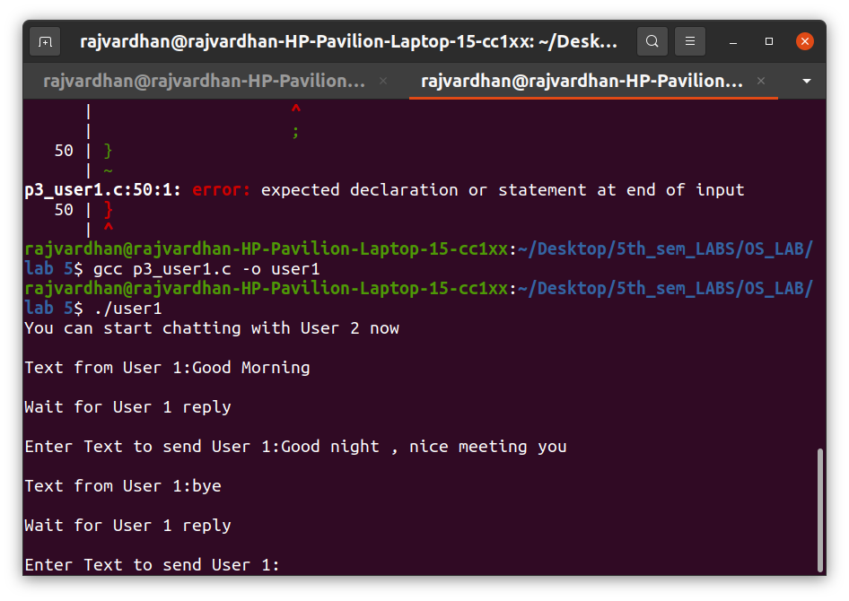

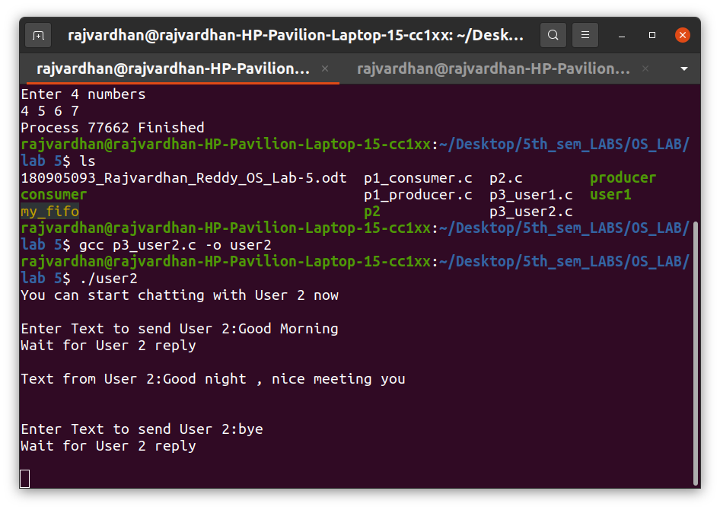

P4) Write a C program reading and writing a binary file in C.

Code :
#include <stdio.h>
#include <stdlib.h>
int main()
{
FILE *fptr;
int num = 0;
fptr = fopen("demo.bin", "wb+");
printf("Enter some numbers : \n");
for (int i = 0; i < 4; i++)
{
scanf("%d", &num);
fwrite(&num, sizeof(int), 1, fptr);
}
printf("Writing done!\n");
fclose(fptr);
fptr = fopen("demo.bin", "rb");
for (int i = 0; i < 4; i++)
{
fread(&num, sizeof(int), 1, fptr);
printf("%d\n", num);
}
}

Output :

